| **TEAM MEMBERS** | **CONTACT INFO** | **ROLES AND RESPONSIBILITIES** |
| --- | --- | --- |
| Qin (Roy) Luo | qluo0008@student.monash.edu | Project Manager   * Keep track of documentation * Version control of documentation * Make sure documentations are delivered appropriately. |
| Jaskaran Singh | jjas0003@student.monash.edu | Product Owner   * Managing the product backlog * Refining the requirements * Reflect any changes to requirements onto the backlogs |
| Isha Kaur | ikau0006@student.monash.edu | Scrum Master   * Ensure team is following the scrum process model * Conduct necessary scrum meetings and retrospection sessions * Facilitate team interactions, and makes sure final decisions are made coherently. |
| Tarin Hridi | thhri1@student.monash.edu | Developer   * Ensure good code design and structure for project * Ensure project’s code base is kept up to date * Ensure front end design of the project is up to standard. |

**VISION STATEMENT:**

For markers and students who need to track student contributions to a group task. The time/task tracker is a web app that tracks which activity each student completes for a project, and the time they spend on the given activity. Unlike traditional marking styles our product allows the marker to handle tricky situations such as ensuring fairness, getting a correct evaluation of student participation and also allows for increased transparency between the student and the marker.

**PROJECT TIMELINE:**

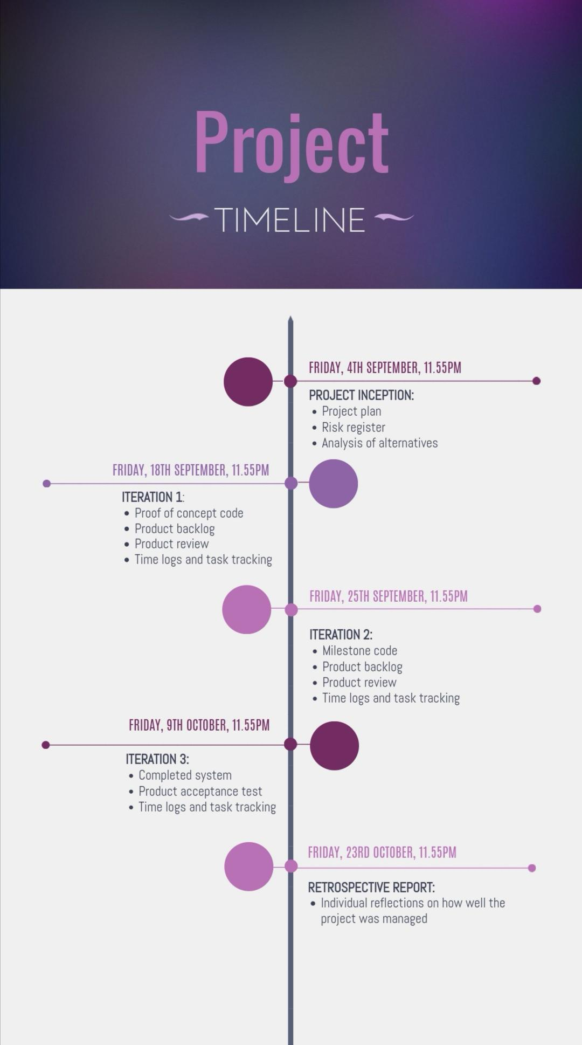

**PROJECT CONTEXT**

Similar to the Scrum process, this project will be developed in an interactive, incremental manner. Sprint iterations will be 9 days each, this is because 7 days is too short a time to effectively complete all the required Sprint tasks to a level of Done, and 2 weeks is too long, and doesn’t allow for extra time between sprints to organise sprint planning sessions and team meetings. Having 9-day iterations is a good compromise, and in addition, allows for wiggle room in regard to meeting deadlines.

Our project will also be utilising the Scrum model format which involves having a Project Manager, a Product Owner, a Scrum Master, and a Developer. This allows us to have a good general basis for the tasks each team member is expected to perform and allows for increased organisation and efficiency.

After completing the project inception, we will create a product backlog, and from this backlog we will extract tasks into our sprint backlog. During each sprint, we will implement the tasks, and after each sprint, we will conduct a product review as a team, and refine our product backlog.

MAIN DIFFERENCES

The main differences which arise when comparing our project model and the scrum model is that firstly, unlike in Scrum, where it’s recommended for teams to hold daily scrum meetings, we will forego these due to the limited timeframe and small team capacity, and as a substitute, if required, will communicate via the online platform Discord in order to update team members on the project and clarify any issues which arise.

Another area of difference is that although we’ve allocated roles and responsibilities within the team, because the team is quite small, and there’s a very small timeframe in which to complete the required tasks, the specific tasks associated with the different roles will be more relaxed in our model. For example, in Scrum the project manager is in charge of documentation, the product owner manages the product backlog and refinements, the scrum master facilitates meetings and aids group discussion and the developer works on the code. However, in our process model all team members will take on these roles, and the cross-functionality of the team will be much more pronounced than would be typically seen in a traditional Scrum model.

**SCRUM CEREMONIES**

SPRINT PLANNING:

The sprint planning process will have two stages, and will occur at least two days before each sprint iteration. In the first phase, the team will review the high-priority items in the Product Backlog, and implement these in the Sprint. Part One focuses on understanding what the client wants and why the specific items are needed. In this phase, the team may also start by devising a Sprint Goal to provide increased clarity and understanding.

Sprint Planning Part Two focuses on how to implement the items that the team decides to take on. To decide this, the team will be using the capacity approach. In the approach, the team will calculate how much time each team member has for Sprint-related work. Once the capacity is determined, the team will figure out how many Product Backlog items they can complete in that time, and how they will go about completing them.

SPRINT REVIEW:

The Sprint Review is an inspect and adapt activity for the product, and it will occur at the end of each sprint. The review will be relatively short, an hour max, and it will involve an in-depth conversation within the team to provide input, learn the situation, get advice and then evolve based on the feedback. In addition, the review will also allow team members, who may have not had the chance, to interact with the software (whichever stage it’s in), become familiar with it and raise any issues/concerns.

RETROSPECTIVE:

The Sprint Retrospective, which follows the Review, involves inspecting and adapting in regard to the process and environment. It’s an opportunity for the Team to discuss what’s working and what’s not working, and agree on changes to try.

**TASK MANAGEMENT**

Tasks will be allocated using the web-based software, Trello. At the start of each assignment, the main tasks will be allocated to each team member. These main tasks will contain subtasks which the allocated individuals must complete within the given timeframe. If more than one member is assigned to a particular main task, then they must add their name to the subtasks which they are in charge of completing.The project and sprint backlogs will be created and updated using Google Docs.

**TIME MANAGEMENT**

For the team’s ease of use and to maximise productivity and efficiency, Trello will also be used to track each member’s contribution (in time) to a given task. Members will self-time and then update their given tasks on Trello with the time it took to complete them. Time will be tracked to the nearest hour and minute, and written in brackets next to each activity the team member completed e.g. a time of an hour and a half would be written as 1 hr 30 min. Since there are 4 members in the team, the work should be divided more or less evenly, and in order to account for this each team member is expected to contribute a minimum of 20% of the total workload. Additionally, to ensure fairness, no team member should be completing more than 30% of the workload.

**DEFINITION OF DONE**

Before we can consider this code done, it needs to have been reviewed by at least 1 other person, and passed the code review (as listed below).

Code review qualities:

* Simple documentation/notes to explain code function
* Make sure that code makes sense - Do I understand what the code does, does the code function as expected
* Test to makes sure code produces correct output by using at least 3 test cases
* Passed the Quality Assurance expectations/standards (as listed in the QA doc)

### 

### Version Control

| Change made: | Made by: | Made on: | Proved by: |
| --- | --- | --- | --- |
| change | Person name | date | Person name |
| Re-estimation of user stories (Product Backlog) | Team | 20/09/2020 | Team |
| Made amendments to definition of done (Project Plan) | Isha Kaur | 21/09/2020 | Team |